Test report

Project information: PetsMeet app
Project name: Application for pet lovers where they can find all information regarding pets, they can connect with other people to share information, go for a walk, adopt pets.
Team assigned: BIljana Resanović
Document overview:
Scope:
Profile page:
Add pet tab
Add pet without choosing pet username
Add pet with uppercase letter and unused name
Add pet with used name
Add pet name
Add breed
Add gender
Add birthday
Add city
Add profile picture
Take photo
Choose from the gallery
Contact form

Home page:
Create a post
Choose picture from gallery
Take a photo and put it on a profile
Type message in dialog
Create a reel
Choose picture from gallery
Take a video

Explore page:
Pet shops tab
Pet friendly tab
Groomers tab
Vets tab
Adoptions tab

Not in scope:
Reels page
Conversations tab in Home page
Notifications in Home page
Map in Home page
Explore in Explore page
Pet page
Walk pet
Lost pet
Adoption

Test objective:
Found 5 bugs with medium priority
All 5 bugs are functional bugs

The number of cases executed: 25
The number of test cases passed: 20
The number of test cases failed: 5
The number of test cases skipped: 9
Pass percentage: 80%
Fail percentage: 20%
Skipped percentage:

Comments:
Blockers and critical issues are not found.
Skipped sections are:
Reels page
Conversations tab in Home page
Notifications in Home page
Map in Home page
Explore in Explore page
Pet page
Walk pet
Lost pet
Adoption
Tests are skipped because other testers tested them or the functionality is not complete yet.
Defects:
Total number of bugs: 5
Breakdown by severity and priority:
There are 5 functional bugs. All with medium severity/priority.

Testing executed:
Exploratory testing

Test executed details:
Summary bug 1:
Pet Shops tab - user is not redirected to pet shops site after click on Pet Shops icon tab in Explore tab.
Expected result: The site www is opened in the browser and application is stayed in the background.
Actual result: After click on icon "Park za pse", user stayed on the Pet Shops page.

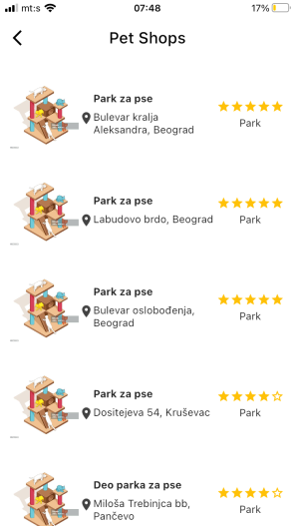

Summary bug 2:

Pet Friendly tab - user is not redirected to the Pet friendly site after click on pet friendly icon tab.
Expected result: The site www is opened in the browser and application is stayed in the background.
Actual result: After click on icon "Park za pse", user stayed on the Pet Friendly page.
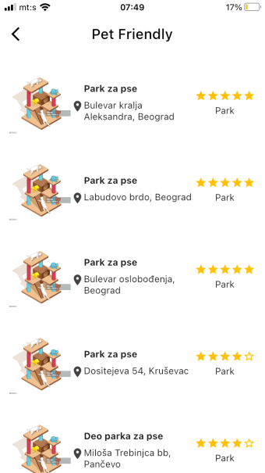

Summary bug 3:

Groomers tab - user is not transferred to the Premium pet Batajnica site after click on its icon.
Expected result: The site www is opened in the browser and application is stayed in the background.
Actual result: After click on icon "Premium pet Batajnica", user stayed on the Groomers page.

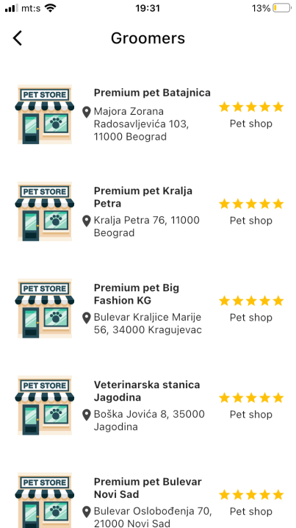
Summary bug 4:
Vets tab - user is not transferred to the "Premium pet Batajnica" site after click on its icon.
Expected result: The site www is opened in the browser and application is stayed in the background.
Actual result: After click on icon "Premium pet Batajnica", user stayed on the Vets page.

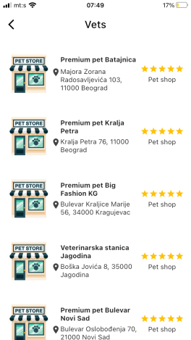

Summary bug 5:
Adoptions tab - user cannot see the list of pets for adoptioning.
Expected result: User should be able to be informed from the list about all pets that are ready for adoption.
Actual result: After click on icon "Premium pet Batajnica", user stayed on the Adoptions page.

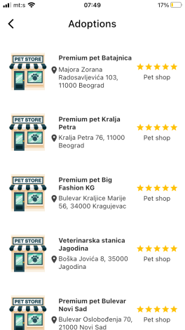

Test environment:
Device:
Mobile phone iPhone 6s

Recommendations:

1.Improvement:
Current: Resolution on icons for achievements and profile in profile tab is low.
Request: Both have to be more coloured.
Reason: Better user experience.

2.Improvement:
Current: In Navigation menu, on icon explore it is written Istrazite nasi partnere
Request: It has to be “Istrazite nase partnere”.
Reason: Language mistake.

3.Improvement:
Current: When we click on the icon Petshops in Explore tab, there are no pictures of petshops
Request: Add pictures of petshops
Reason: To give users more information about petshops. And it is easy to remember it through picture for user.

4.Improvement:
Current: After click on the icon Add pet in Profile tab, title gender is written on the top of the box and under in the box is written choosen gender.
Request: Gender should be written like others information, in the box and there should be a dropdown menu from where user can choose gender.
Reason: All topics in the pet basic info boxes should be the same. If there is some more information in some box, it should be a dropbox.

5.Improvement:
Current: When click on the icon Pet friendly in Explore tab, there are information about parks for dog.
Request: Add partners which are pet friendly (restaurants, apartments, shops). Add their pictures, websites, contact, address).
Reason: Users will be informed about all pets friendly places near them.

6.Improvement:
Current: When click on the icon Adoptions in Explore tab, there are information about pet store and vet.
Request: Add all information about adopting pets (pictures, contact, adress).
Reason: Users will be informed about all pets for adoptioning near them.

7.Improvement:
Current: When click on the icon Vets in Explore tab, there are information about pet store and one vet.
Request: Add all information about vets (pictures, contact, address, website, open hours).
Reason: User can choose a nearest vet station and will be informed about it.

Exit criteria:
No critical bugs are found.

